Please start by saving this file with the name: GUID_Surname_ENG5059P_Prelim_year

Please tick appropriate project:

ENG5059P (MSc)

Student Name | ADEWALE, AYODELE ADEOKIJI
Student GUID Number | 2695754A
Degree programme | COMPUTER SYSTEMS ENGINEERING
Working Title of Project | UNDERSTANDING CROSS-SECTIONAL AND LONGITUDINAL MICROBIAL PROFILES OF PIT LATRINES
Name of Supervisor(s) | UMER IJAZ
Academic year | 2021-2022

Your report should include the below subject headings, should be no more than 4 pages and be incorporated within this document:

Introduction
A lack of access to proper sanitation methods and good water exposes billions of people globally to several health risks such as infectious diarrhea and intestinal infections. According to the WHO 56% of the world population have access to a safely managed sanitation service, 34% use private sanitation facilities that has its waste water treated, 20% use toilets or laterines where excreta is disposed of in situ and 78% use atleast a basic sanitatory method (World Health Organisation (WHO), 2022). Despite efforts to provide modern sanitatory methods globally pit latrines are still used by 1.7 billion people globally , often in developing countries where they provide a low-tech and low-cost solution. Due to lack of proper waste treatment, usage (e.g number of users), construction method and location, maintenance of these facilities is a challenging problem from health and sanitary perspective.
While work is ongoing to provide access to proper sanitatory methods globally it is important to make pit laterines more sanitory and healthy. Since the main activity in pit latrines is guided by microbial processes, i.e., decomposition of the faecal material, the main aim of the project is to understand the microbial community data and the associated environmental factors, that can reveal insights about the composition of these latrines, as well as identify factors that are associated with the pit latrine fill ups. For this purpose, the 16S rRNA samples are available for latrines from two countries, Tanzania, and Vietnam, which will be analysed to identify potentially important bacteria and environmental variables. The project involves studying recent methods in microbial ecology particularly those that give insights into underlying ecological phenomena

Aims/Objectives of project
- Determining the microbial communities present in pit laterines.
- Analysising the effects of environmental factors on the microbial communities present in pit latries
- Studying the microbial communities present in pit laterines to determine how they affect decomposition of feacal material.

Resources required
- R and R studio.
- Knowledge of microbial communities.
- The dataset.
- Knowledge of the algorithms reguired to carry out analysis on the samples.
- References.

GANTT CHART

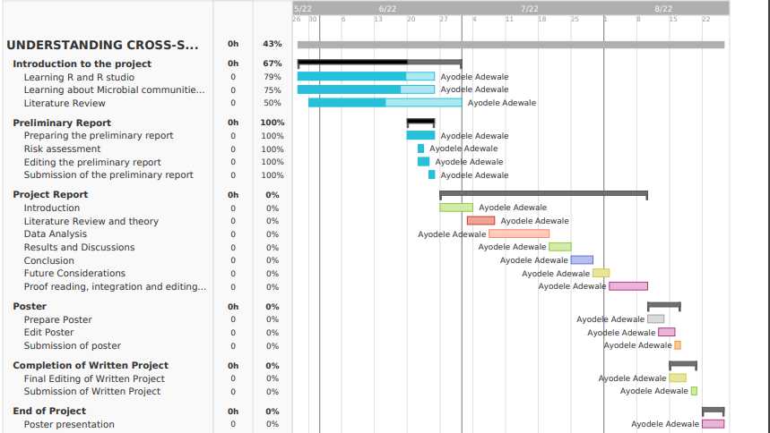

Risk assessment
The project has an overall low risk because it is a desk based data analysis project where no live experiment is going to be carried out. Listed below are potential risks that can be encounted out while the project is on:

Risk: Mental fatigue
Likelihood without control measures: Likely
Severity: Moderate
Control measures to mitigate risk: The project involves support of additional volunteers (who are PhD students/PDRAs associated with the supervisor's lab), as well as benefits from working in a team environment, with specific and measurable weekly milestones, ensuring the work is balanced in the duration of the project. The training and support is provided by the supervisory team, and access to statistical tools (existing programming codes from numerous projects) ensures reduced anxiety and concerns.
Likelihood with control measures: Likely

Risk: Data corruption
Likelihood without control measures: Unlikely
Severity: Moderate
Control measures to mitigate risk: The project data is provided on a Dropbox repository (which maintains history for 30 days), as well as saved as a local copy on personnel computer, and in the event of data corruption, the extra copies will be used
Likelihood with control measures: Unlikely

Risk: Unavailability of data
Likelihood without control measures: Improbable
Severity: Slight
Control measures to mitigate risk: The data for the project is provided by the supervisor, and is available on a shared repository as well as a backed up
Likelihood with control measures: Improbable

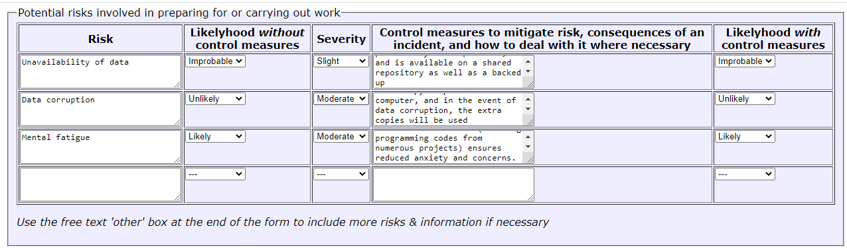

Name of next of kin: Oluwadimimu Adewale
Phone Number: +447360900816

